Abstract___________________________________________________________
Clustering is an important analysis method commonly used in many areas, including data mining, image processing, statistics, biology, and machine learning. In this report, we study about few factors that deteriorate the performance of the k- means algorithm, and how much this deterioration can be overcome either by using a better initialization technique, or by little modification of the algorithm. Our main finding is that when the clusters overlap, how k-means can be significantly improved by removal of a number of observations to make a well separated group of clusters for better conclusion. Simple furthest point heuristic reduces the number of erroneous clusters from 15% to 6%, on average.(1) This accuracy is more than enough for most pattern recognition applications. However, when the data has well separated clusters, the performance of k-means depends completely on the goodness of the initialization. Therefore, if high clustering accuracy is needed, a better algorithm should be used instead.

Introduction________________________________________________________

- What is Cluster Analysis?
Cluster analysis groups data objects based on information found only in the data that describes the objects and their relationships. The goal is that the objects within a group be similar (or related) to one another and different from (or unrelated to) the objects in other groups. The greater the similarity (or homogeneity) within a group and the greater the difference between groups, the better or more distinct the clustering.(2)
One application of Clustering: A clustering algorithm can be employed to reveal the groups in which feature vectors are clustered in the L (>=2)-dimensional feature space. Points that correspond to the same ground cover type, such as water, are expected to cluster together and form groups. Once this is done, the analyst can identify the type of each cluster by associating a sample of points in each group with available reference ground data, that is, maps or visits. below figure demonstrates the procedure.(3)

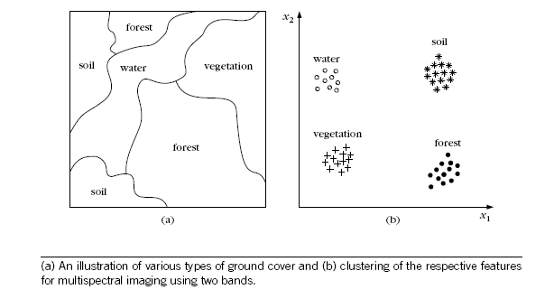

- What is Well-Separated Clusters?
Clustering aims to find useful groups of objects (clusters), where usefulness is defined by the goals of the data analysis. Well-Separated cluster is a set of objects in which each object is closer (or more similar) to every other object in the cluster than to any object not in the cluster. Sometimes a threshold is used to specify that all the objects in a cluster must be sufficiently close (or similar) to one another. This idealistic definition of a cluster is satisfied only when the data contains natural clusters that are quite far from each other. Below figure gives an example of well-separated clusters that consists of three groups of points in a two-dimensional space.(4)

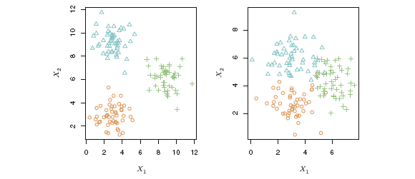
A clustering data set involving three groups. Each group is shown using a different colored symbol. Left: The three groups are well-separated. In this setting, a clustering approach should successfully identify the three groups. Right: There is some overlap among the groups. Now the clustering task is more challenging.

- Importance of well separated clusters:
The main principles of clustering are homogeneity, meaning that objects of the same cluster are maximally close to each other, and separation, meaning that objects in separate clusters are maximally far apart from each other.(5) It is challenging to devise a proper clustering method given a data set not-well-separated. When the squared error criterion is used, outliers can unduly influence the clusters that are found. In particular, when outliers are present, the resulting cluster centroids (prototypes) are typically not as representative as they otherwise would be and thus, the SSE will be higher. Because of this, it is often useful to discover outliers and eliminate them beforehand.(2) A quintessential example of partitioning methods is K-means that has attracted considerable interest because of its computational efficiency and performances. However, its final solution quality can be greatly influenced by the outliers and the initial centroids selected at random. (6) That’s why in this report, a modified K-means++ method is to be implemented to help us for better and unambiguous conclusion regarding the allocation of the individuals to the appropriate disjoint clusters.

What is the optimum number of Clusters (K)? ________________________________________

One of the main difficulties for cluster analysis is that, the correct number of clusters of different types of datasets is seldom known in practice. However, most of clustering algorithms are designed only to investigate the inherited grouping or partition of data objects according to a known number of clusters. Thus, identifying the number of clusters is an important task for any clustering problem in practice albeit it must be faced with many operational challenges. Several algorithms have been proposed in the literature for clustering-means clustering is a simple and elegant approach for partitioning a data set into K distinct, non-overlapping clusters. To perform K-means clustering, we must first specify the desired number of clusters K; then the K-means algorithm will assign each observation to exactly one of the K clusters. Below figure shows the results obtained from performing K-means clustering on a simulated example consisting of 150 observations in two dimensions, using three different values of K. (4)
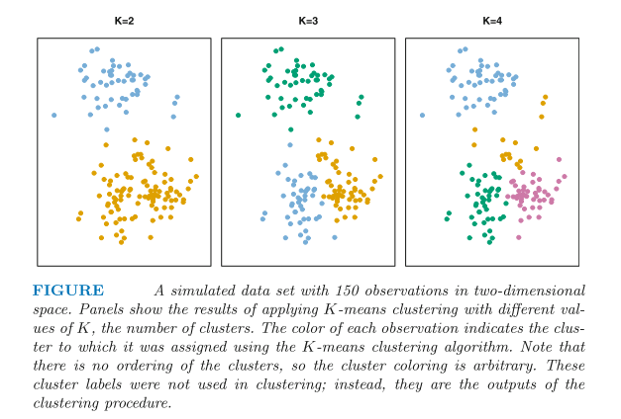
In the literature several approaches have been proposed to determine the number of clusters for k-mean clustering algorithm. We focus on 4 different approaches to cross validate the exact number of clusters: i) Elbow method; ii) Percentage of variance explained plot iii) Distortion evaluation plot; iv) Jump Statistics.

- Elbow method and % of variance explained plot: (7)
The oldest method for determining the true number of clusters in a data set is inelegantly called the elbow method. It is a visual method. The idea is that Start with K=1, and keep increasing it in each step by 1, calculating your clusters and the Total within sum-of-squares (WSS) that comes with the training. At some value for K the WSS drops dramatically, and after that it reaches a plateau when you increase it further. This is the K value you want. This elbow method can also be represented by plotting the percentage of variance explained (ratio of the between-group variance to the total variance) against k, the first N clusters should add significant information, explaining variance; yet, some eventual value of k will result in a much less significant gain in information, and it is at this point that the graph will provide a noticeable angle.
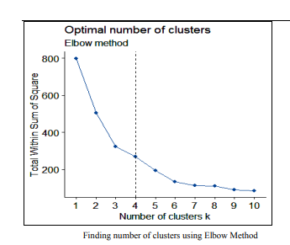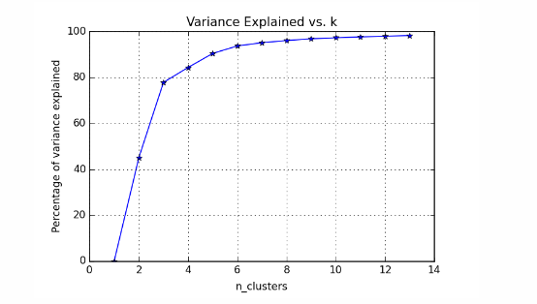

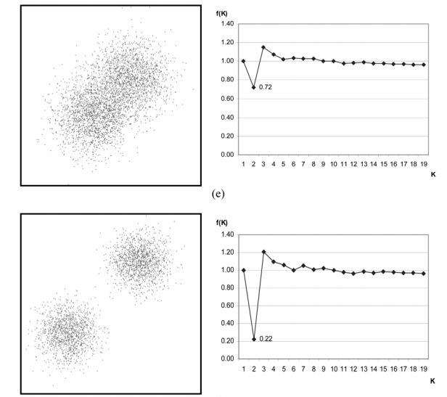
- Distortion evaluation function plot: (8)
This method is based on a distortion evaluation function f(k).
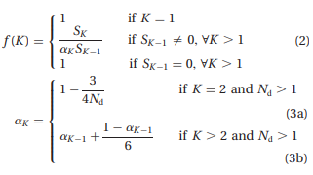
Where, S_{K} is the sum of the cluster distortions when the number of clusters is K, N_{d} is the number of data set attributes (i.e. the number of dimensions) and a_{K} is a weight factor. The value of f(K) is the ratio of the real distortion to the estimated distortion and is close to 1 when the data distribution is uniform. The values of K that yield small f(K) can be regarded as giving well-defined clusters.

- Jump Statistics (Information Theoretic Approach):(9)
The procedure is based on "distortion," which is a measure of within-cluster dispersion. Formally, let X be a p-dimensional random variable with a mixture distribution of G components, each with covariance Г; let C₁, C₂…., C_{k} be a set of candidate cluster centers; and let C_{x} be the one closest to X. Then the minimum achievable distortion associated with fitting k centers to the data is
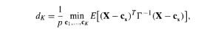
Which is simply the average Mahalanobis distance, per dimension between X and C_{x}. In practice one generally estimates d_{k} using$\hat{d_{k}}$, the minimum distortion obtained by applying the k-means clustering algorithm to the observed data. The jump is defined as J(K) =${\hat{{ d}_{k}}}^{(-\frac{p}{2})} - {\hat{d_{k-1}}}^{(-\frac{p}{2})}$ , assuming ${\hat{{ d}_{0}}}^{(-\frac{p}{2})}$=0.
The maximum jump J(K) corresponds to the right number of clusters. This is supported with a mathematical derivation stating that if the data can be considered a standard sample from a mixture of Gaussian distributions at which distances between centroids are great enough, then the maximum jump would indeed occur at K equal to the number of Gaussian components in the mixture. We are going use this procedure only when the other 3 methods are not able to give a conclusive result.

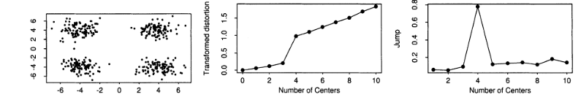

Proposed Clustering Algorithm_________________________________________

- What is the initialization procedure?
K-means is a good algorithm for local fine-tuning but it has serious limitation to relocate the centroids when the clusters do not overlap. It is therefore unrealistic to expect the clustering problem to be solved simply by inventing a better initialization for k-means. The question is merely, how much a better initialization can compensate for the weakness of k-means.(1)
According to Arthur, David and Sergei Vassilvitski (2007),(10) the k-means++ algorithm propose a specific way of choosing these centers. At any given time, let D(x) denotes the shortest distance from a data point x to the closest center we have already chosen. Then, we define the following algorithm for initialization,
- Choose an initial center C₁ uniformly at random from all the data points, say χ.
- Choose the next center C_{i} , selecting C_{i} = x’ ∈ χ with probability ${{D(x^{'})}^{2}}/{\sum_{X ∈ χ}{{D(x)}^{2}}}$
- Repeat Step 2 until we have chosen a total of k centers.
A little modification is made on the above algorithm is by taking the extreme point (furthest from overall centroid) as the initial center C₁ instead of any random point in the step 1. Moreover, in step2 the single simulation scheme can be slightly changed by taking the mode of 1000 simulation, which will make the initialization process more stable with the achievement of Furthest point heuristic (1)also in addition.
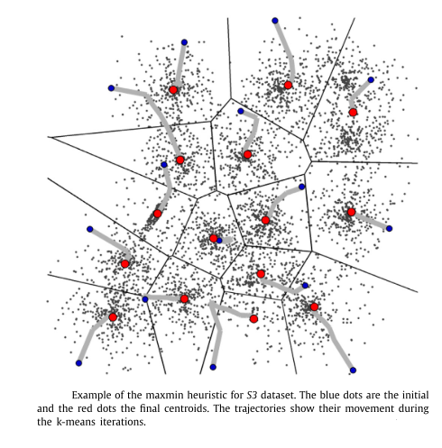

- Allocation of the observations:
Step1. After obtaining the Initial centers, observations are getting allocated in K-clusters as per the minimum Euclidean distance criterion (from the corresponding K centers).
Step2. For the K clusters, we can calculate K mean vectors. Step3. For each of the observations, K Euclidean distances [d_{i}²= (X_{i}-${\overline{X}}_{k}$)^{T}(X_{i}-${\overline{X}}_{k}$)] will be evaluated .Next, we allocate the observations based on the minimum distance criterion. And again we repeat the process until the clusters remain fixed / the stability will be achieved. (That can be empirically implemented by considering the fact that the difference between objective functions [G_{n}= $∑_{k=1}^{K}∑_{Xi∊Ϲk}$ (X_{i}-${\overline{X}}_{k}$)^{T}(X_{i}-${\overline{X}}_{k}$) ] at the n^{th} and n-1th iteration would be significantly small.

- Making of Well Separated Clusters:
After getting the stable K clusters, we are going to consider following steps to make a group of K-well separated clusters in terms of Euclidean distance.
Step1. Determine the cluster that contains largest no. of observations. Step2.Then, start with a random observation (say i) from that cluster, we are going to check whether B_{i} (Distance of the i^{th} observation from the center where it belongs) is less than Ai (Minimum of distances of the i^{th} observation from all observations in the other clusters where it does not belong) or not. Step3. If the observation does not follow the criteria of the step2, it will be removed from the cluster and step2 will be continued until all the observations are checked. Step4. Step1-3 will be done for all the other clusters except the preceding one.
After going through all the 4 steps we will get the final well-separated clusters from the concept that Radius (J^{th} cluster) < Distance (J, Z) for any other cluster Z∊ {1, 2... K} - {J}.

Experimental results and discussion_____________________________________
The main objective of the study is to provide a well separated cluster and to achieve this we are going to consider 10 different examples where the clusters are overlapped but not disjoint. A Synthetic data set and few real datasets are used to validate the proposed clustering algorithm in this study. An artificial bivariate data set named ‘xclara’, consisting of 3000 points in 3 clusters, is going to be considered first.(11) On the other hand, 8 real datasets, collected from the UCI Machine learning Repository,(12) include Iris, Old Faithful Geyser Data, Banknote Authentication, Blood Transfusion, Breast Cancer, HTRU2 & Wi-Fi localization, are used to implement the proposed well-separated clustering procedure. Lastly, an image (RGB) data of Google logo is considered from GitHub repository.(13) Table 1 lists the information of the considered 9 datasets.

Among these 9 examples xclara and Faithful Geyser datasets are bivariate, so we are showing these two datasets separately to visualize each and the every steps of our proposed algorithm in the below mentioned Figures 1 and 2, followed by other real datasets which are multivariate. That’s why for those multi feature datasets, we are using 2-D or 3-D principal Component plots to visualize the outcomes in Figures 3 & 4.

Table1. Information of the tested benchmark datasets
Data sets | Size | Attribute | Cluster
xclara | 3000 (1000, 1000, 1000) | 2 | 3
Iris | 150 (50,50,50) | 4 | 3
Faithful Geyser data | 272 | 2 | 2
Banknote Authentication | 1372 (762, 610) | 5 | 2
Blood Transfusion service center | 748 (570, 178) | 4 | 2
Breast Cancer Wisconsin(original) dataset | 699 (16 excluded due to missing values)  (570,183) | 9 | 2
HTRU2 | 17898 (16259, 1639) | 8 | 2
Wi-Fi Localization | 2000 (500, 500, 500, 500) | 7 | 4
Google.jpg (RGB image) | 182×442 pixels | 3 | 3 / 4 / 5

xclara  A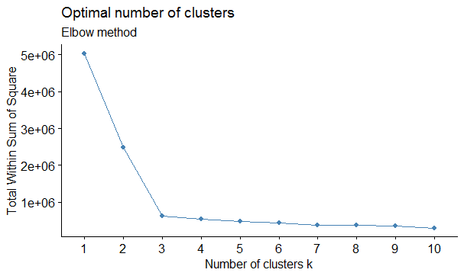 | Faithful Geyser data  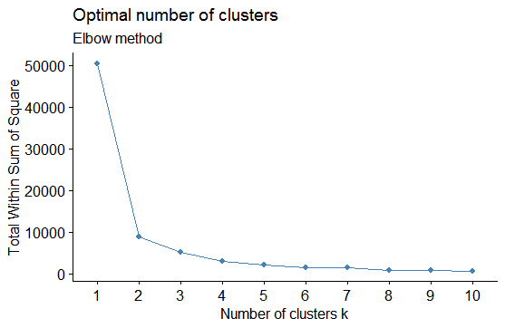
B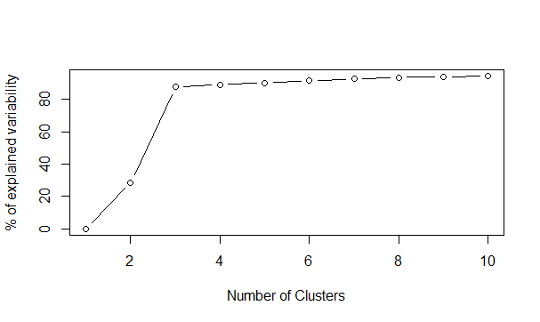 | 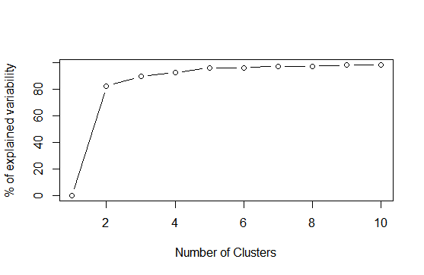
C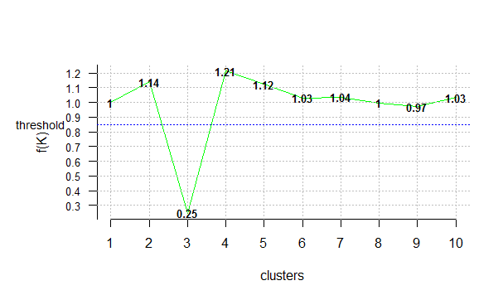 | 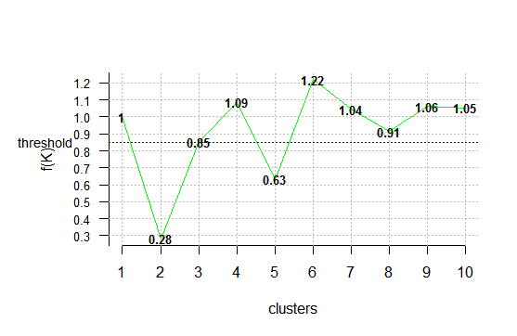

Figure1. Optimum no. of K-means Clustering A. Elbow method B. % of variance explained plot C. distortion function plot.
Clearly, all the three plots are indicating that xclara data has 3 clusters where faithful data has 2 based on underlined definition of those methods.

xclara  A 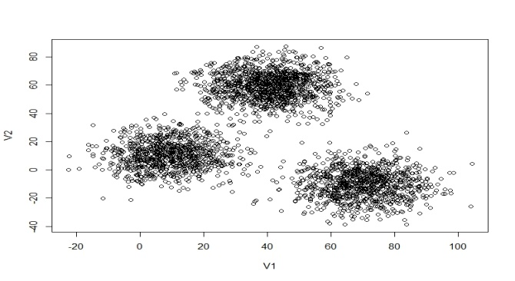 | Faithful Geyser data  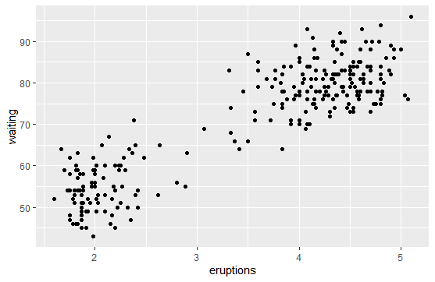
B 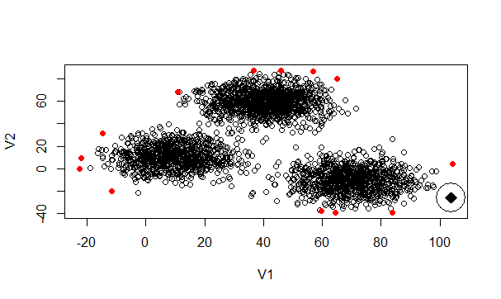 | 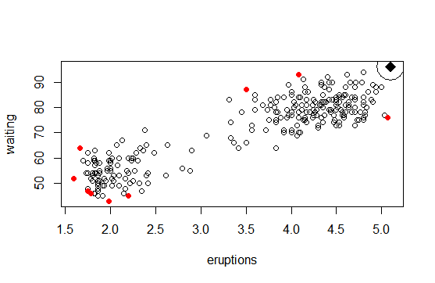
C 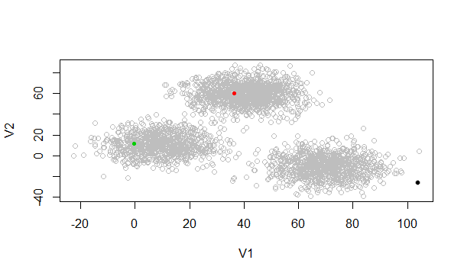 | 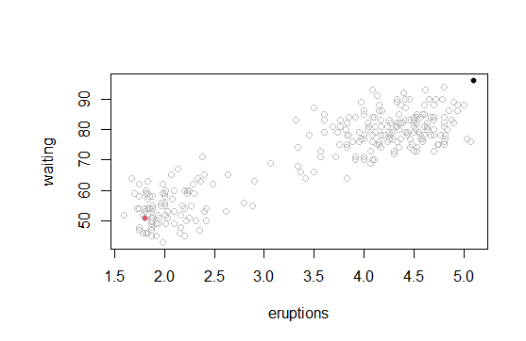
D 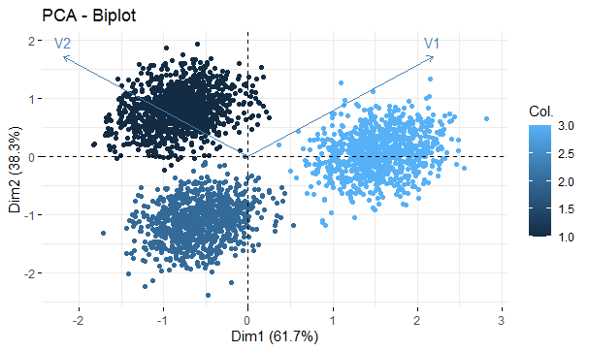 | 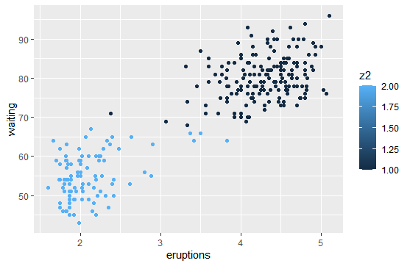
E 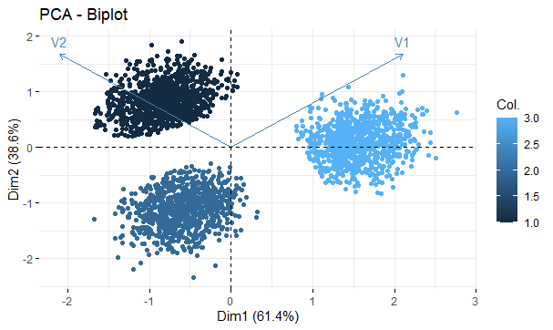 | 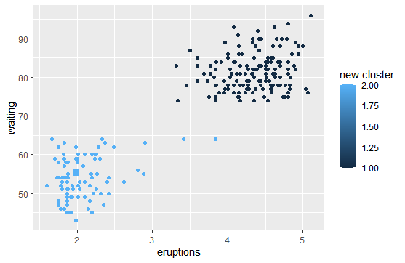

Figure2. Clustering results A. Original Structure B. finding the extreme point C. initial centroids for K-means D. K-means Clustering E. Well-separated clustering structure.

Overlapped k-means clustered data | Well-separated clustered data
A 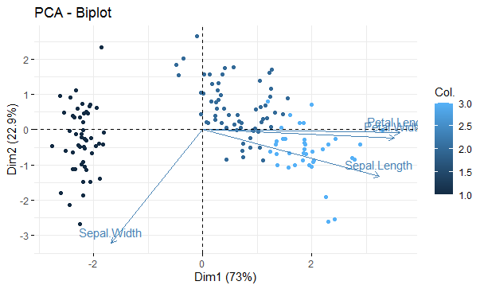 | 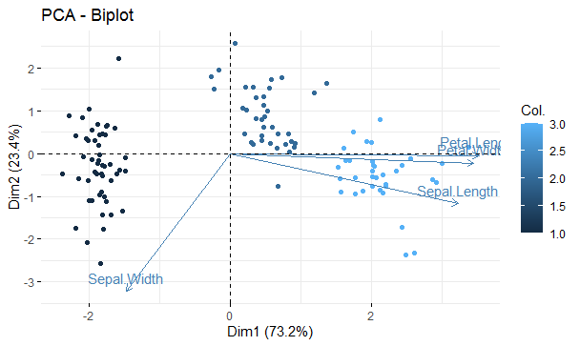
B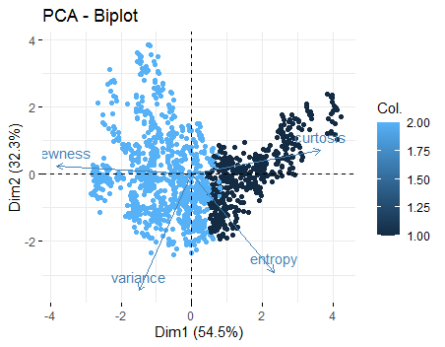 | 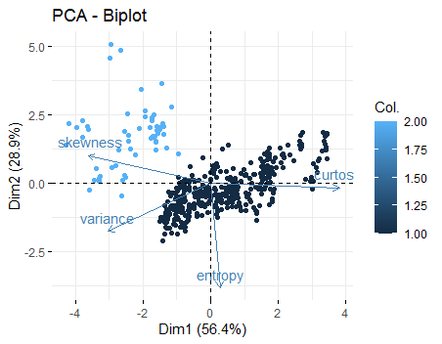
C 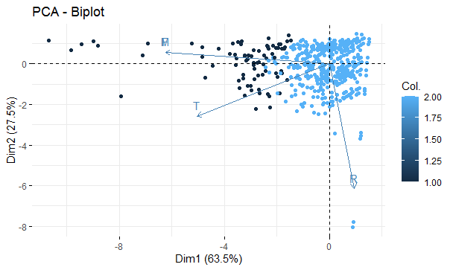 | 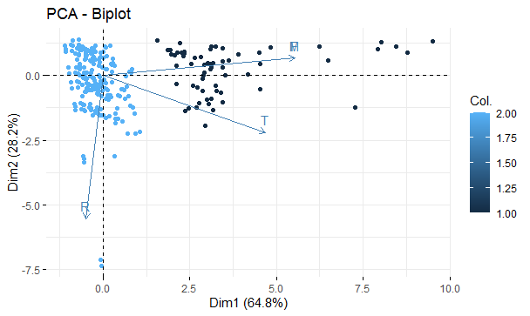
D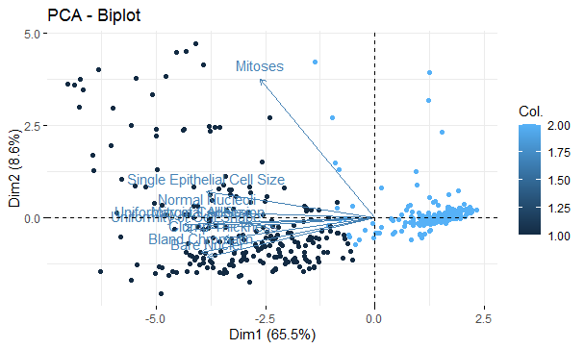 | 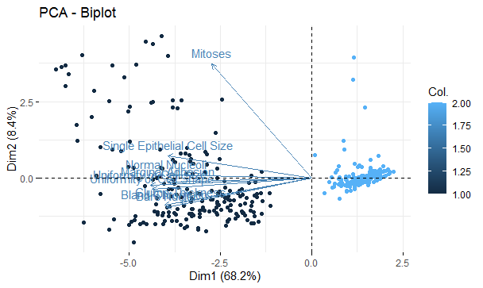
E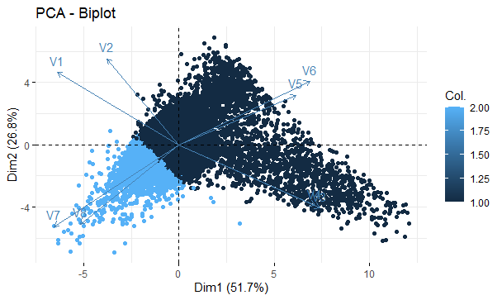 | 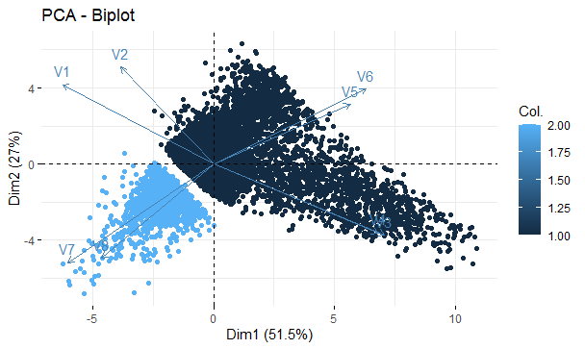
F 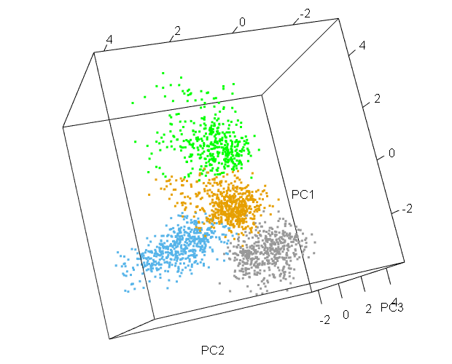 | 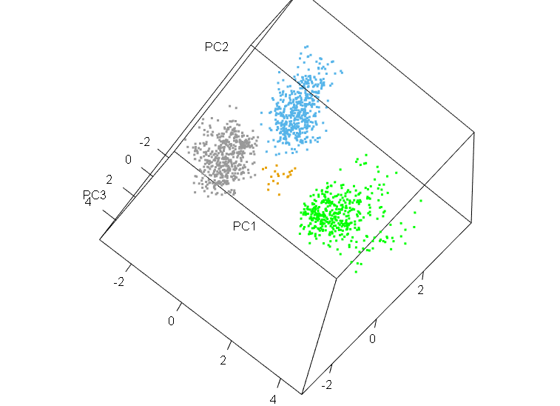
Figure3. Clustering of multi features datasets A. Iris B. Banknote Authentication C. Blood Transfusion D. Breast Cancer data E. HTRU2 data F. Wi-Fi localization dataset.
A 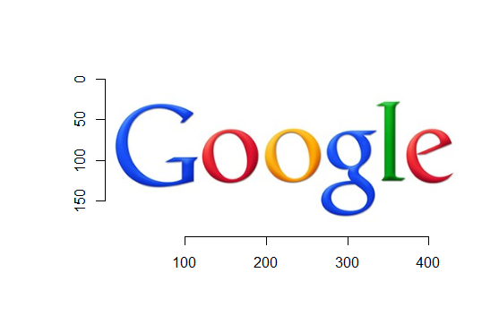
B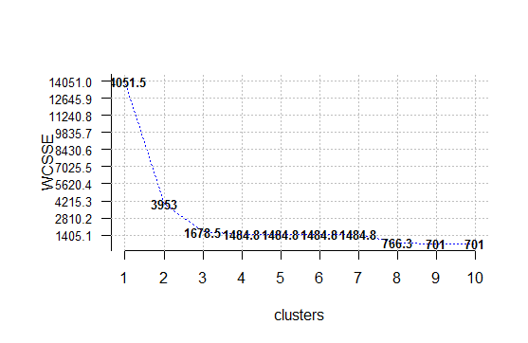 | 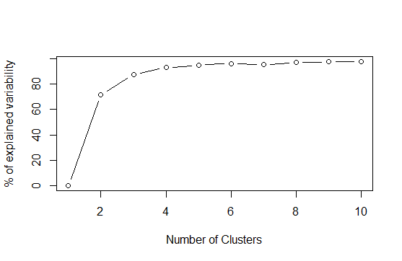 | 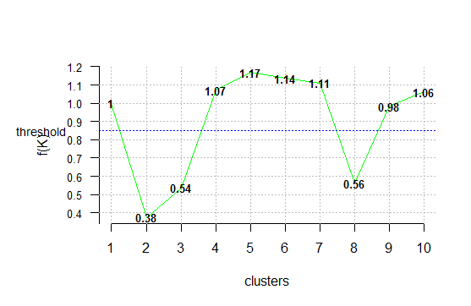
k=3  C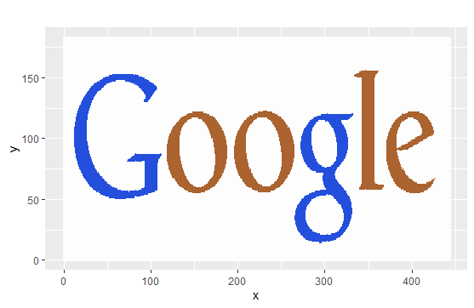 | k=4  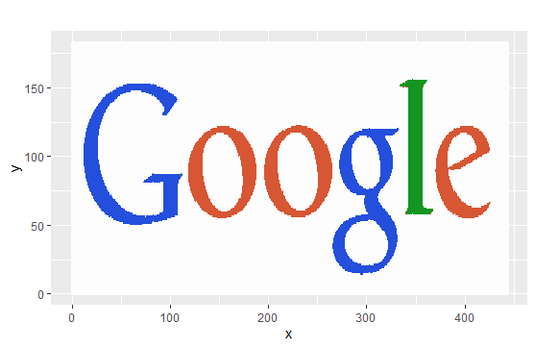 | 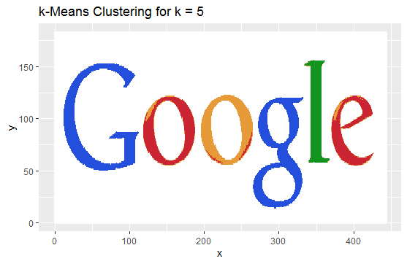
D 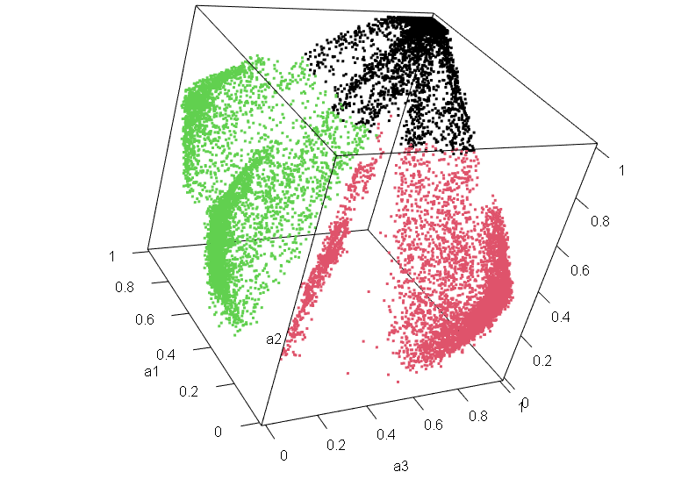 | 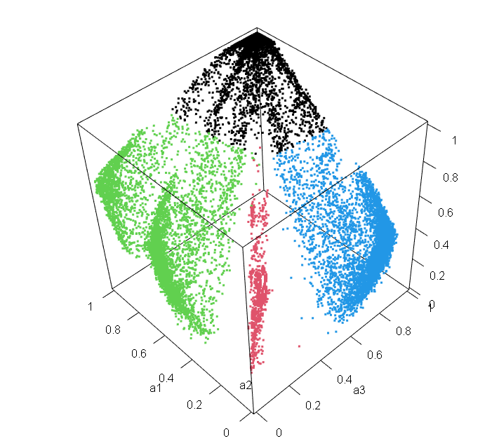 | 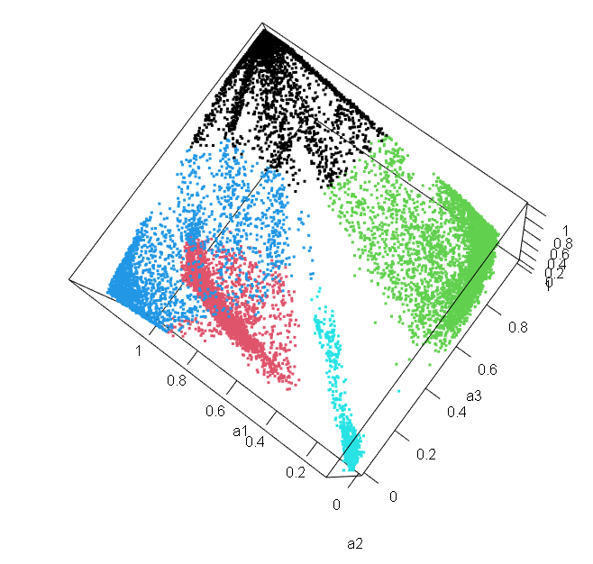
E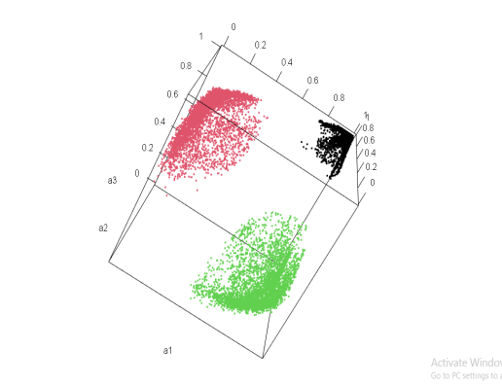 | 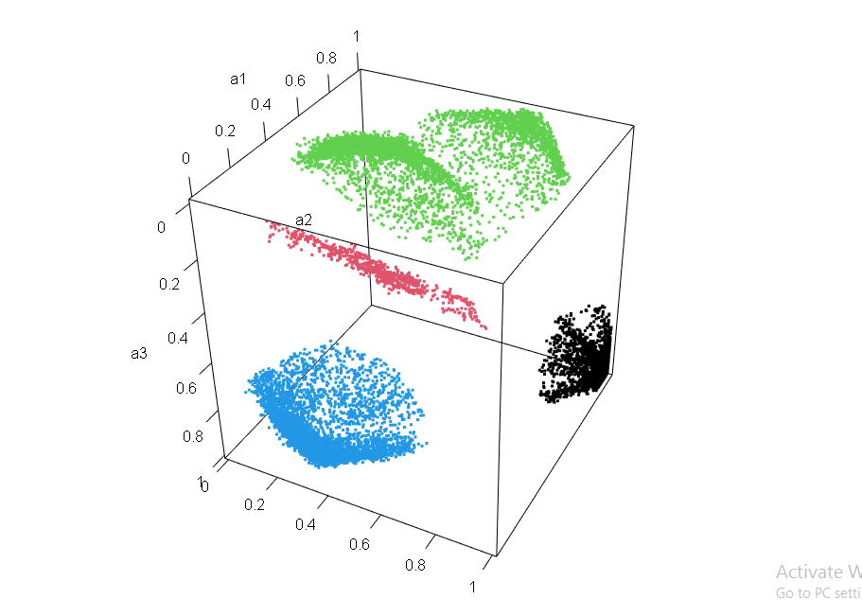 | 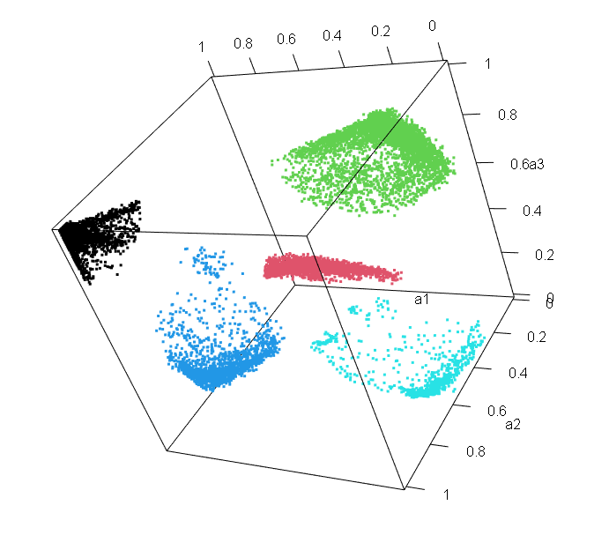
Figure4. Clustering results of RGB image A. Original image B. Optimum no. of image clusters (k=3) C. K-means clustered images for k=3, 4 &5 D. 3-D plot of R,G & B features after implementation of k-means++. E. Final well-separated clustering structure.
Clustering Validity___________________________________________________

The term cluster validation is used to design the procedure of evaluating the goodness of clustering algorithm results. The evaluation measures, or indices, that are applied to judge various aspects of cluster validity are traditionally classified into the following three types.
- Internal tests measure the goodness of a clustering structure without respect to external information. An example of this is the SSE. Unsupervised measures of cluster validity are often further divided into two classes: measures of cluster cohesion (compactness, tightness), which determine how closely related the objects in a cluster are, and measures of cluster separation (isolation), which determine how distinct or well-separated a cluster is from other clusters.(2)(3)
- External tests measure the extent to which the clustering structure discovered by a clustering algorithm matches some external structure. An example of a supervised index is entropy, which measures how well cluster labels match externally supplied class labels.
- Relative tests compare different clusters. A relative cluster evaluation measure is a supervised or unsupervised evaluation measure that is used for the purpose of comparison. Thus, relative measures are not actually a separate type of cluster evaluation measure, but are instead a specific use of such measures. As an example, two K-means clustering can be compared using either the SSE or entropy.
In this study, among various measures we are going to implement Rand Index (RI), Folkes & Mallows Index (FMI), Jaccard Index (JI) as external validity indices and Dunn Index (DI), Silhouette index (SI), Davies Bouldin index (DBI)and Calinski Harabasz index (CHI) for internal Clustering validity. (14), (15)

- Results of Cluster Validation:
From the previous plots it is quite clear that we have already achieved well-separated clusters from the respective centroid based clusters. Now we are going to observe whether it improves clustering outcome by considering clustering validity indices on 6 already classified data from our previously used examples.
Among earlier mentioned clustering indices, the range of SI varies from -1 to +1, where a high value depicts that the data point is well matched to its own group and poorly matched to neighbor groups. On the other hand, for the indices like, RI, FMI & JI the highest value i.e. 1 indicates no mismatch whereas the lowest value i.e. 0 represents complete mismatch. A higher DI, CHI and lower DBI depict better clustering.(16) With the help of CRAN R package “clusterCrit”(17) we evaluate the above mentioned cluster indices. Table-2 provides the results corresponding to the clustering validity of our proposed well-separated clustering.

Table2. Results of cluster validity indices

 |  | K-mean++ | well-separated |  | K-mean++ | well-separated |  | K-mean++ | well-separated
Iris | RI | 0.73024 | 0.97846 | Wi-Fi localization | 0.88513 | 0.99461 | HTRU2 | 0.64227 | 0.63723
Iris | JI | 0.69585 | 0.97184 | Wi-Fi localization | 0.84586 | 0.99276 | HTRU2 | 0.63183 | 0.62592
Iris | FMI | 0.82081 | 0.98572 | Wi-Fi localization | 0.91651 | 0.99636 | HTRU2 | 0.77541 | 0.76998
Iris | DI | 0.09881 | 0.35415 | Wi-Fi localization | 0.06696 | 0.19427 | HTRU2 | 0.00155 | 0.09051
Iris | SI | 0.55282 | 0.66483 | Wi-Fi localization | 0.41023 | 0.41729 | HTRU2 | 0.51905 | 0.63735
Iris | DBI | 0.72558 | 0.55367 | Wi-Fi localization | 0.97063 | 0.79875 | HTRU2 | 0.67968 | 0.53299
Iris | CHI | 561.628 | 642.097 | Wi-Fi localization | 1854.874 | 1718.152 | HTRU2 | 16950.01 | 21797.93
Bank  Authentication | RI | 0.52485 | 0.50055 | Blood Transfusion | 0.61402 | 0.65255 | Breast Cancer data | 0.92395 | 0.97192
Bank  Authentication | JI | 0.38047 | 0.43813 | Blood Transfusion | 0.57803 | 0.61204 | Breast Cancer data | 0.87034 | 0.95144
Bank  Authentication | FMI | 0.55177 | 0.62445 | Blood Transfusion | 0.73772 | 0.76099 | Breast Cancer data | 0.93070 | 0.97512
Bank  Authentication | DI | 0.01454 | 0.23935 | Blood Transfusion | 0.02631 | 0.16216 | Breast Cancer data | 0.15545 | 0.35315
Bank  Authentication | SI | 0.43228 | 0.52536 | Blood Transfusion | 0.60232 | 0.73472 | Breast Cancer data | 0.51893 | 0.56968
Bank  Authentication | DBI | 0.93994 | 0.66933 | Blood Transfusion | 0.57672 | 0.41473 | Breast Cancer data | 0.75726 | 0.35315
Bank  Authentication | CHI | 1423.674 | 319.315 | Blood Transfusion | 963.203 | 1441.185 | Breast Cancer data | 1026.262 | 1237.417

Observations:
The main objective of Table2 is to show the actual importance of well-separated clusters in terms of clustering validity in real datasets. Majority of the external and internal indices show an improvement in their measures when we move from normal K-means++ overlapped clustering to well separation except HTRU2 dataset, where a slight deficit is observed in three indices when move in the same direction (RI: 0.64227 to 0.63723, JI: 0.63183 to 0.62592 and FMI: 0.77541 to 0.76998). In the Banknote authentication dataset, despite of having better results in all internal validity clustering indices, Calinski Harabasz index shows a significant decrement in its measure (1423.674 to 319.315) due to possible reasons like removing a large no. of outliers. Apart from these two exceptions, we have an overall positive and better output of our proposed algorithms compare to k-means ++ based on the Table2 outcomes.

Discussion and Future directions________________________________________
The proposed Well-separated clustering method has certain pros and cons compared to some existing methods.
- It is quite obvious that our proposed algorithm provides a better result compare to K-means++ in terms of cohesion and separation, which can easily be observed from the plots as well as clustering validity measurements. Despite of having this advantage, one main drawback of this procedure is that we are losing a large no. of data. So, to avoid this fact a new technique of matrix transformation of the dataset can be implemented in future to shift the location and position of the clusters to make them disjoint.
- Another problem of this methodology is our algorithm is only limited to applicable on centroid based clustering techniques. It might be possible to find also some separation criteria when k-medoids are going to take under consideration instead of/ or k-means based on the structure of the data.

Conclusion__________________________________________________________

In this work, we put forward an effective well-separated clustering algorithm, which is an improvement over K-mean++ clustering. Furthermore, this method can achieve the discrimination of various clusters with centroid based shapes. The experimental results have shown that our proposed algorithm can work effectively and efficiently in different data sets. The study of data complexity metrics is a promising area of research in the field of clustering. It deserves further study. So, we would focus on the analysis of several dataset characteristics to retrieve information from them and this could further be considered to design the proper clustering algorithm.

Bibliography:
1. Fränti P, Sieranoja S. How much can k-means be improved by using better initialization and repeats? Pattern Recognit. 2019;93:95–112.
2. Analysis C, Concepts B. Cluster analysis. Data Handl Sci Technol. 1998;20(PART 2):57–86.
3. Theodoridis S, Pikrakis A, Koutroumbas K, Cavouras D. Introduction to Pattern Recognition: A Matlab Approach. Introduction to Pattern Recognition: A Matlab Approach. 2010.
4. James G, Witten D, Hastie T, Tibshirani R. An introduction to Statistical Learning. Current medicinal chemistry. 2000.
5. Gondeau A, Aouabed Z, Hijri M, Peres-Neto P, Makarenkov V. Object weighting: a new clustering approach to deal with outliers and cluster overlap in computational biology. IEEE/ACM Trans Comput Biol Bioinforma. 2019;(c):1–1.
6. Xu X, Li J, Zhou MC, Xu J, Cao J. Accelerated Two-Stage Particle Swarm Optimization for Clustering Not-Well-Separated Data. IEEE Trans Syst Man, Cybern Syst. 2018;PP:1–12.
7. Maheswari K. Finding Best Possible Number of Clusters using K-Means Algorithm. 2019;(1):533–8.
8. Yuan C, Yang H, Centre ME. Selection of K in K -means clustering. J. 2005;219(May 2004):103–19.
9. Sugar CA, James GM. Finding the Number of Clusters in a Dataset: An Information-Theoretic Approach. J Am Stat Assoc. 2003;98(463):750–63.
10. Arthur D, Vassilvitskii S. K-means++: The advantages of careful seeding. Proc Annu ACM-SIAM Symp Discret Algorithms. 2007;07-09-Janu:1027–35.
11. Struyf A, Hubert M, Rousseeuw PJ. Clustering in an object-oriented environment. Journal of Statistical Software. 1996.
12. Asuncion A, Newman DJ. UCI Machine Learning Repository: Data Sets. University of California Irvine School of Information. 2007.
13. GitHub. About GitHub. https://github.com/about. 2017.
14. Yatskiv I. The methods of cluster analysis results validation. Proc Int Conf RelSta. 2015;6(1):75.
15. Charrad M, Ghazzali N, Boiteau V, Niknafs A. Nbclust: An R package for determining the relevant number of clusters in a data set. J Stat Softw. 2014;61(6):1–36.
16. Karlekar A, Seal A, Krejcar O, Gonzalo-Martin C. Fuzzy K-means using non-linear S-Distance. IEEE Access. 2019;7:55121–31.
17. Desgraupes B. Clustering Indices. CRAN Packag [Internet]. 2013;(April):1–10. Available from: cran.r-project.org/web/packages/clusterCrit

